**Method**

In the field of human-computer interaction, the user-centered design methodology has been widely adopted as a means of creating systems that are both usable and effective. This approach emphasizes the importance of understanding the needs, wants, and limitations of users in the design process. In the context of information retrieval, user-centered design has been utilized to better align search engine approaches with users' expectations. For example, studies such as Giltrow & Stein (2009) "Genres of the Internet" have employed focus groups to gather data on users' perceptions of different genres of websites. This data is then used to develop categories for labeling websites and improving the effectiveness of indexing. This approach has also been validated in a Spotify study, in which users were asked to identify different styles and types of podcasts through a qualitative focus group study. The styles identified were then grouped together and tested for retrieval.

A similar approach was employed to gain a better understanding of users' perceptions and expectations regarding the categorization of art. The rationale for this approach is that users' prior knowledge and understanding of art categories will, to some extent, influence their ability to index and retrieve art effectively. To gather data on users' perceptions, a focus group study was conducted in Miro, in which participants were asked to identify and write down different styles, types, and genres of art that they believed existed. These responses were then grouped together and analyzed to identify unique categories. These categories could then be used to inform the visual aspect of retrieval, such as by labeling a set of artwork based on some of the identified categories and testing a vision model's ability to predict them.

Afterwards, the participants navigated to the Rijksmuseums digital art collection in order to find out how the participants search for art in databases and what their expectations are. They had one open-ended task: to find art-work that appeals to them. Afterwards, the participants were asked to reflect on their experience and relevancy of retrieved results.

**Participants**

The focus group consisted of 5 participants that were recruited using a convenience sample. While the limitations of this approach are acknowledged (in that the results might not be generalizable to a wider population), the present study does not seek to confirm any hypothesis but to gather an in-depth understanding of potential users. No inclusion/exclusion criteria has been pre-defined. The participant demographics can be seen in table 1.

| **Participant nr.** | **Gender** | **Age** | **Nationality** | **Background** |
| --- | --- | --- | --- | --- |
|  |  |  |  |  |
| 1 | Female | 26 | French | Medicine |
| 2 | Female | 21 | Italian | Marketing |
| 3 | Male | 31 | Latvian | Business |
| 4 | Male | 25 | Lithuanian | Hospitality |
| 5 | Male | 28 | Croatian | Computer Sc. |
|  |  |  |  |  |

**Art Categories per Participant**

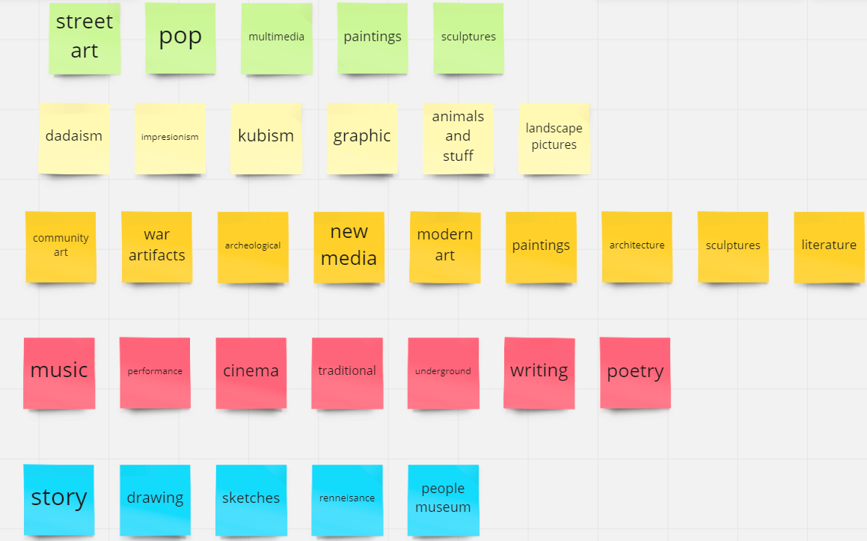

**Rijkstudio**

**What we like**

The Rijksstudio's search feature has a clean user interface and offers many filters to refine searches, including options for materials, colors, and techniques. However, the user may find it difficult to navigate and find relevant results. The "Stories" section of the website, which showcases selected masterpieces from the museum, is preferred by the user over the search feature.

**The User Experience**

The participants conducted a user study by searching for the artists, centuries and type of artwork on the "Search Rijksstudio" website. The participant found that while searching for the artist by name displayed various artworks, using the "advanced search" to search for "Bartholomeus van der Helst" as the manufacturer did not return any results. The participants also experienced difficulty searching for specific types of art and found that the website's ranking system was not very useful. The participants suggested that the website should have a personalized landing page and a program that guides users through exhibitions, displaying information about the artists, the exhibition's time period, and the types of art on display. The participants also mentioned that it would be helpful to have a button that shows users what they are looking for and that the website's collection should be better organized. Overall, the participants found the website's search function and UI confusing and suggested that the website needs a landing page that takes users through the collection in an organized and easy-to-understand way.

**User Feedback**

The website of the art museum was perceived as confusing to navigate, and difficult to find specific information. The "stories" page of the site is a better resource for understanding what's on display. The search results are not always relevant to the query, and the user interface is not user-friendly. The layout of the site is not intuitive, and the images are too large, making it hard to view multiple items at once. The "sort by" options are limited, and it would be more useful to be able to sort by the name of the artwork, or when the pieces were added to the collection. Overall, the website could benefit from a more streamlined and intuitive design, with a better user experience in mind, whereas the retrieved artwork needs to be matched better to the search query.